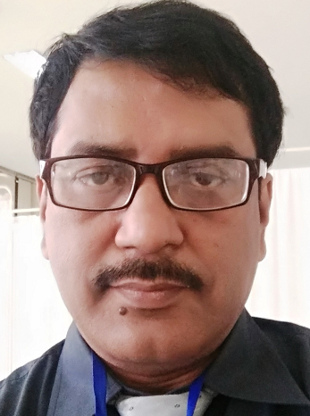

Name: Gautam Das
Qualification: MD(Anesth), FIPP, FIAPM
Mail id: gdas2310@gmail.com
Professional experience:
1. 1996-2002: Consultant Anaesthesiologist & Pain Physician at Dum Dum Municipal Specialised hospital and cancer research Centre, Kolkata
2. 2002-2005: In-charge of Pain Clinic Bhattacharya Orthopedics & Related Research Center, Kolkata
3. 2005-2007: In-charge of Pain Clinic at Charnock Hospital, Kolkata
4. 2007 to till date: Director, Daradia Pain Clinic Kolkata
5. 2006 to 2018: Consultant & faculty at B.R.Singh Hospital, Eastern Railway
Achievements:
1. Stood 1st in MD (Anesth) exam at Calcutta University
2. World Institute of Pain awarded “Excellence in Pain Practice” in all 3 categories, “research in pain management”, “multidisciplinary pain practice” & “training of physicians”, 1st time in Asia in 2010
3. In Feb 2011, Indian Society for Study of Pain (Indian chapter of International Association for Study of Pain) declared Daradia Pain Clinic as “Best Pain Clinic” in India
4. 2007-2012: Chairman of India, Pakistan, Bangladesh, Sri Lanka & Iran chapter of World Institute of Pain
5. 2009-2012: Member of educational committee of Indian Society for Study of Pain (ISSP task force)
6. 2017: President-Elect, Indian Society for Study of Pain
7. 2018-19: President, Indian Society for Study of Pain

Publications:
1. Publication of Books: author & editor of many popular pain management books
Title of the Book |  | Name of the Publisher | Year of publication
1. | How to start & run a pain clinic | Wiley | 2013
2. | Clinical methods in pain medicine- 2nd Ed | CBS Publishers | 2016
3. | Common Pain Management Procedures | Daradia Pain Foundation | 2013
4. | Basics of Pain Management- 2nd Ed | CBS Publishers | 1st ed in 2016, 2nd ed in 2019
5. | MCQ in Pain Medicine (with Dr. Chinmoy Roy) | CBS Publishers | 2019

2. Publication of Book chapters: Written 13 book chapters published from India and abroad

3. Publication in journal: 73 publications at national & international journals. 6 most important publications are given below
Title of the article |  | Name of the Journal |  | Year of publication
An Alternative Technique for Transaortic Celiac |  | Indian Journal Pain |  | May 2009
Plexus Block
Ozone Nucleolysis for Management of Pain and |  | Interventional |  | Sept 2009
Disability in Prolapsed Lumber Intervertebral Disc |  | Neuroradiology
A Prospective Cohort Study

Neuropathic Pain and Depression: A Prospective Study to find out Any Association |  | Journal on Recent Advances in Pain |  | Jan 2016
Evidence and consensus recommendations for the |  | Journal of Pain Research |  | March 2017
pharmacological management of pain in India

Rami Communicans Block Prior to Transforaminal Endoscopic Discectomy relieves Procedure Pain Significantly and adds Safety: A Case–control Study |  | Journal on Recent Advances in Pain |  | May 2017
Addressing the barriers related with opioid therapy for management of chronic pain in India |  | Pain Management |  | July 2017

Role in Pain education:
- Running short courses/workshops and one-year fellowship programs which have been attended by more than 1200 doctors from India and abroad.
- 2009 to till date: Examiner of FIPP (Fellowship in Interventional Pain Practice) examination, Maastricht, Netherlands, New York & Miami, USA.
- Examiner of FIAPM
- 2009 to till date: Faculty & Examiner, World Institute of Pain, USA
- Co-guide at PhD program in pain, JSS University, Mysore, Karnataka
- Faculty of IASP-ISSP multidisciplinary pain management program at AIIMS, New Delhi
- 2011 to 2018: Course Director & Visiting faculty, Padjadjaran University, Bandung, Indonesia
- 2015- till date: Visiting Faculty, One year pain management fellowship, ESI Institute of Pain Management, West Bengal Health University
- 2014-till present date: Adjunct Faculty, Datta Meghe Institute of Health Sciences, Wardha, Maharasthra
- 2017 to till date: Visiting honorary faculty at R. G. Kar Medical college for pain management fellowship at R. G. Kar Medical College, West Bengal Health University
- External examiner of pain fellowship exam at Bharati Vidyapith, Pune 2019
- 20012-2016: Chief Executive Editor, Indian Journal of Pain (Official journal of ISSP)
- 2015 to till date: Editor-in-chief, Journal on Recent Advance in Pain www.jorapain.com

