Dr. Pradeep Jain for President Elect ISSP 2020
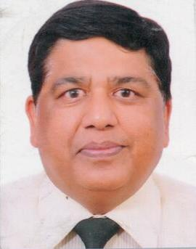

PROF. (DR) PRADEEP JAIN MD, FICA, FIAPM
Vice Chairperson
Director, Pain Management Services
Department of Anaesthesiology, Pain and Perioperative Medicine
Sir Ganga Ram Hospital, New Delhi

Registrar: Indian Academy of Pain Medicine (IAPM)
Fellow: Indian Academy of Pain Medicine (FIAPM) & Indian College of Anaesthesiologists (FICA)
Organizing secretary: 33rd National Conference of Indian Society for Study of Pain (ISSPCON 2018) Delhi
Twice Governing Council Member of ISSP
Course Coordinator: Post doctoral certificate course in pain management at Sir Ganga Ram Hospital, New Delhi
Award: ‘Path Finder in Pain Education’ award for the contribution in the field of Pain and Palliative Care at
Delhi PAINCON 2019 and ‘Pain Ambassador Award’ at Pune ICRA 2019
Ex-President & Secretary: Indian Society for Study of Pain (ISSP) Delhi Branch
Member: Indian Advisory Board for IASP-ISSP Multidisciplinary Evidence-Based Pain Management Program
Executive Member: Committee of IASP India Pain Management Camp programme 2016
Felicitated by the All India Jain Society for conducting Pain Relief Camp and Charitable work for the needy people and received ‘Honour’ from Delhi Jain Jaiswal Sabha 2012
Director: Post doctoral certificate course in pain management
Teaching Coordinator: Postgraduate Students at Sir Ganga Ram Hospital
Trustee & Founder Member: Indian College of Anaesthesiologists (ICA)
Member Board of Management: Sir Ganga Ram City Hospital, New Delhi
Professor: Ganga Ram Institute for Postgraduate Medical Education & Research (GRIPMER)
Author: Atlas on ‘Procedures in Neonate and Pediatric Practice’ including pain management
Publications: Several National and International papers and book chapters
Conducted: Several Live and Cadaveric workshops, Free Pain Relief camps
Ex-Secretary: Delhi Jain Society

