DR.MRS.KIRAN VYAWAHARE
SR. CONSULTANT PAIN AND ANAESTHESIA
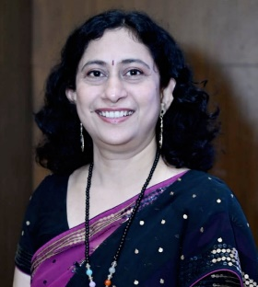
PRESIDENT ELECT ISSP NAGPUR 2022-25
PAST HON SECRETARY ISSP NAGPUR 2018-22
IMM.PAST PRESIDENT OF INDIAN SOCIETY OF ANAESTHESIOLOGIST NAGPUR- WON BEST CITY BRANCH AWARD AT NATIONAL AND STATE
PRESIDENT APPRECIATION AWARD AT NATIONAL AND STATE ISA -2022
BEST PUBLIC AWARENESS AWARD AT STATE ISA 2022, 2019 AT NATIONAL AND STATE
PAIN FELLOWSHIP AT BANNER BAYWOOD HOSPITAL, PHOENIX, USA.2008
PRESENTED PAPER AT WORLD PAIN CONGRESS AT BOSTON USA, 2018
FIPM FROM DPMC 2014 AND DARADIA PAIN CLINIC 2018
FIAPM [ FELLOW OF INDIAN ACADEMY OF PAIN MEDICINE] JULY 2021
PAST HON SECRETARY ISA NAGPUR IN 2016 [WON BEST BRANCH AT STATE AND NATIONAL]
FACULTY AT NATIONAL ISSP AT BHUBANESHWAR 2022
CHAIRED MANY SESSIONS AT CONFERENCES
ZTCC AWARD FOR FILM ON ORGAN DONATION 2022
PIONEER IN KTP AT WOCKHARDT, WORKED IN NEURO, ORTHO, LAPAROSCOPIC AND KNEE REPLACEMENT SURGERIES
HAS STARTED YOU TUBE CHANNEL FOR ANAESTHESIA AWARENESS-28 K VIEWS, 534 Subscribers
SCRIPT AND DIRECTION OF 2 PLAYS ON: MEDICOLEGAL ASPECTS OF ANAESTHESIA AND HISTORY OF ANAESTHESIA
RECENTLY WON ISA STAR AWARD AT NATIONAL LEVEL 2019[for poem on covid pandemic]
WOMAN OF THE YEAR 2022

